**Laporan Praktikum**

**Pemrograman Web 1**



Nama : Muhamad Hafizh Albar

NIM : 20230810161

Kelas : TINFC-2023-04

**Teknik Informatika**

**Fakultas Ilmu Komputer**

**Universitas Kuningan**

Tugas

<!DOCTYPE html>

<html lang="en">

<head>

<meta charset="UTF-8">

<meta name="viewport" content="width=device-width, initial-scale=1.0">

<title>Best Hotel</title>

<!-- Bootstrap CSS -->

<link href="https://cdn.jsdelivr.net/npm/bootstrap@5.3.0/dist/css/bootstrap.min.css" rel="stylesheet">

<style>

/* Dropdown hover style */

.dropdown:hover .dropdown-menu {

display: block;

}

/* Style for image grid */

.image-grid img {

width: 100%;

height: auto;

border: 1px solid #ddd;

padding: 5px;

}

.image-grid .image-item {

text-align: center;

margin-bottom: 15px;

}

</style>

</head>

<body>

<!-- Header -->

<header class="bg-dark text-white text-center py-4">

<h1>BEST HOTEL</h1>

</header>

<!-- Navigation Menu -->

<nav class="bg-secondary">

<div class="container">

<ul class="nav justify-content-center py-2">

<li class="nav-item"><a class="nav-link text-white" href="#home">Home</a></li>

<li class="nav-item"><a class="nav-link text-white" href="#kamar">Kamar</a></li>

<li class="nav-item dropdown">

<a class="nav-link text-white dropdown-toggle" href="#fasilitas" id="fasilitasDropdown" role="button" data-bs-toggle="dropdown" aria-expanded="false">Fasilitas</a>

<ul class="dropdown-menu">

<li><a class="dropdown-item" href="#petualangan">Petualangan Alam</a></li>

<li class="dropdown-submenu">

<a class="dropdown-item dropdown-toggle" href="#kolam">Kolam Renang</a>

<ul class="dropdown-menu">

<li><a class="dropdown-item" href="#sumber-air-panas">Sumber Air Panas</a></li>

<li class="dropdown-submenu">

<a class="dropdown-item dropdown-toggle" href="#kolam-anak-dewasa">Kolam Anak & Dewasa</a>

<ul class="dropdown-menu">

<li><a class="dropdown-item" href="#reguler">Reguler</a></li>

<li><a class="dropdown-item" href="#premium">Premium</a></li>

</ul>

</li>

</ul>

</li>

<li><a class="dropdown-item" href="#kebugaran">Pusat Kebugaran</a></li>

<li><a class="dropdown-item" href="#ruang-rapat">Ruang Rapat</a></li>

</ul>

</li>

<li class="nav-item"><a class="nav-link text-white" href="#pesan">Pesan Sekarang</a></li>

</ul>

</div>

</nav>

<!-- Main Layout -->

<main class="container my-4">

<div class="row">

<!-- Leftbar with Video -->

<div class="col-md-4 mb-3">

<div class="d-flex flex-column">

<video src="../../Video/1%20KAMAR%202%20LANTAI%20CUMA%20200RB-AN%20SEMALAM.mp4" title="Leftbar Video 1" class="w-100 mb-3" controls style="height: 200px; border: none;"></video>

<video src="../../Video/1%20KAMAR%202%20LANTAI%20CUMA%20200RB-AN%20SEMALAM.mp4" title="Leftbar Video 1" class="w-100 mb-3" controls style="height: 200px; border: none;"></video>

<video src="../../Video/1%20KAMAR%202%20LANTAI%20CUMA%20200RB-AN%20SEMALAM.mp4" title="Leftbar Video 1" class="w-100 mb-3" controls style="height: 200px; border: none;"></video>

</div>

</div>

<!-- Right Content with Images -->

<div class="col-md-8">

<div class="row image-grid">

<div class="col-sm-4 image-item">

<img src="../../Img/pexels-pixabay-164595.jpg" height="150" width="150" alt="Image 1">

<p>Image Description 1</p>

</div>

<div class="col-sm-4 image-item">

<img src="../../Img/pexels-pixabay-164595.jpg" height="150" width="150" alt="Image 2">

<p>Image Description 2</p>

</div>

<div class="col-sm-4 image-item">

<img src="../../Img/pexels-pixabay-164595.jpg" height="150" width="150" alt="Image 3">

<p>Image Description 3</p>

</div>

<div class="col-sm-4 image-item">

<img src="../../Img/pexels-pixabay-164595.jpg" height="150" width="150" alt="Image 4">

<p>Image Description 4</p>

</div>

<div class="col-sm-4 image-item">

<img src="../../Img/pexels-pixabay-164595.jpg" height="150" width="150" alt="Image 5">

<p>Image Description 5</p>

</div>

<div class="col-sm-4 image-item">

<img src="../../Img/pexels-pixabay-164595.jpg" height="150" width="150" alt="Image 6">

<p>Image Description 6</p>

</div>

</div>

</div>

</div>

</main>

<!-- Footer -->

<footer class="bg-dark text-white text-center py-3">

<p class="mb-0">&copy; 2024 Best Hotel. Semua Hak Dilindungi.</p>

</footer>

<!-- Bootstrap JS -->

<script src="https://cdn.jsdelivr.net/npm/bootstrap@5.3.0/dist/js/bootstrap.bundle.min.js"></script>

</body>

</html>

Hasil:

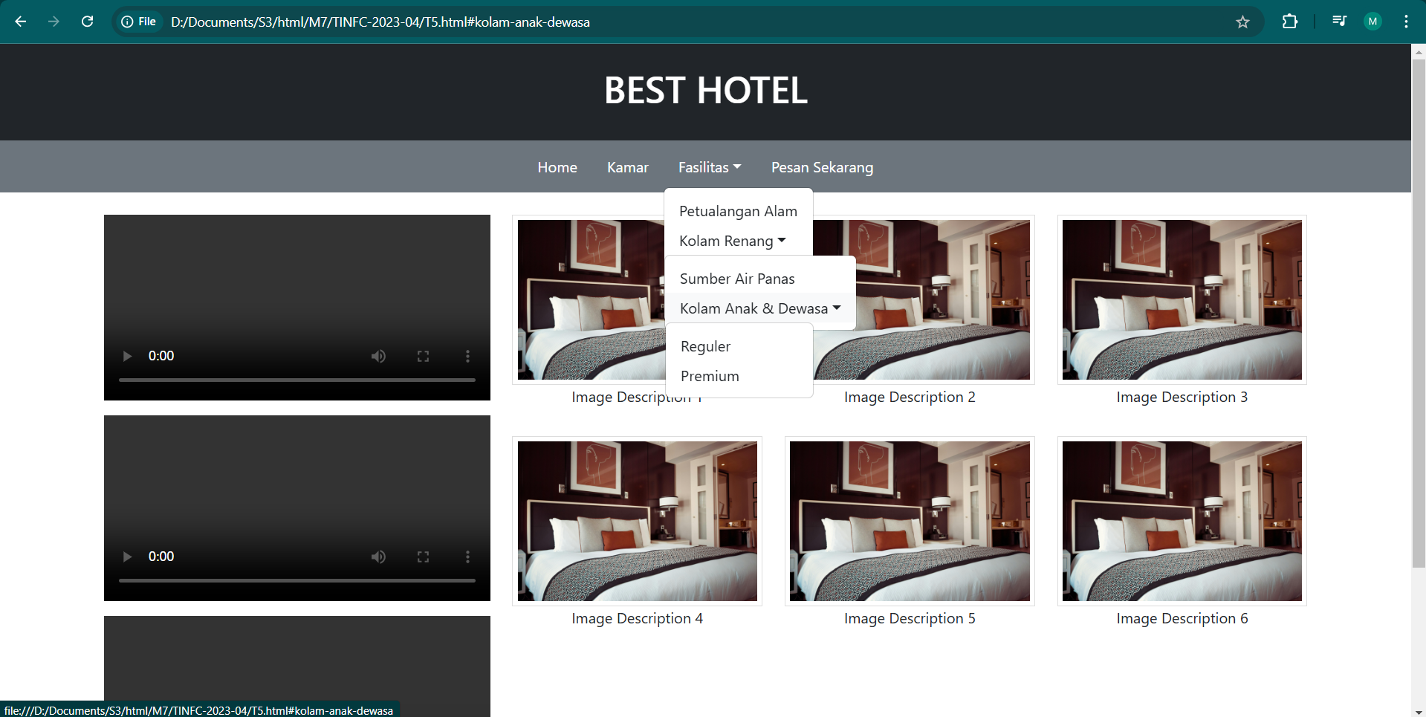

Elemen seperti header, navigasi, dan footer didefinisikan dengan gaya Bootstrap, sedangkan tambahan CSS digunakan untuk memperbaiki dropdown hover dan tata letak galeri gambar.